Brian Kihneman
Behavioral Strategy Memorandum
3/1/16

The Carter Racing team is presented with two decision choices under uncertainty: race or withdraw. There are several outcome states associated with the decision to race and a single outcome associated with the decision to withdraw. The scenario analysis is represented by the following cost-benefit summary:
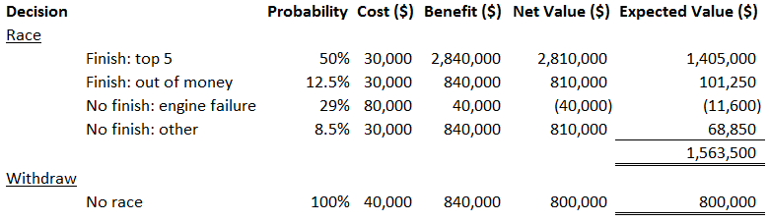
The analysis shows that the expected value of racing is greater than the expected value of withdrawing. Carter racing should choose to race based on the cost-benefit analysis. Note: the opportunity cost of losing the $800,000 oil sponsorship because of engine failure is not factored in the analysis, but if it was, the total expected value of racing would still exceed withdrawal.
However, the analysis is based on the assumption that engine failure and ambient temperature are independent and unrelated – that 29% of all races over the long-run will result in engine failure. This assumption is a hasty generalization based on a small, incomplete data set (the relationship between temperature and gasket failure given by the engine mechanic). A more complete picture is needed in order to better assess the relationship between temperature and engine failure. The missing data is the number of races and temperatures for which the engine did not fail. Also, the decision makers are assuming that engine failure is a result of damaged head gaskets (even though the engine was failing for several reasons). The Chi-Square test of independence matrix should look something like this:
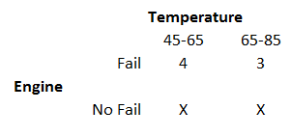
The engine failure data provided in the case is incomplete and unreliable. Relying on the data would be a hasty generalization. Acceptance of the limited data for decision making would represent a confirmation bias (WYSIATI) whereby the decision maker is relying on System 1 thinking to confirm the assumption that there is no relationship between temperature and engine failure, and that engines failed due to damaged head gaskets. No further deliberation is exercised to form a broader picture of the situation. The reward for racing is so great that WYSIATI clouds alternative judgements. The halo effect of the preliminary data is strong. Moreover, the engine failure report given in the case was provided by a single engine mechanic. Separate judgements on the issue should be considered by several people. The engine mechanic’s argument is based off a “gut feeling” that the cold temperature was damaging head gaskets and causing engine failure. In a sense, the engine mechanic is exhibiting an availability bias because he is recollecting specific instances in the past that he believes are indicative of a temperature vs. engine failure relationship. On the other hand, the chief mechanic is also biased because he believes “luck is an important element in success” and does not provide evidence that the temperature vs. engine failure relationship is truly random. He chooses to confirm his own predilection that engine failure is random by denouncing the data provided by the engine mechanic.
The decision maker also needs to consider framing the situation based on wants vs. needs. Is Carter Racing willing to take on the risk of disastrous long-term consequences (losing a need) for the chance of securing a Goodyear contract (a want)? In other words, is the want of a Goodyear contract worth the risk of losing the need of an oil sponsorship? Note: one can argue that the Goodyear sponsorship is a “need” but the case states that Carter Racing “cannot live without the oil sponsorship.” Does the decision maker frame the problem from a risk or reward perspective?
The perceptions of both technical experts are biased and do not consider all relevant data. The team must not make the mistake of focusing on shared information that is incomplete or unreliable.

